Folk and Popular Culture: Key Issue 1

***Where Do Folk and Popular Cultures Originate and Diffuse?***

Rubenstein, pp. 115-120

This section looks at the origin and diffusion of specific examples of both folk and popular culture. Specifically examined examples of folk culture are FOLK MUSIC and AMISH CULTURE. Examples used to illustrate popular culture are POPULAR MUSIC and SOCCER.

# ● ORIGIN OF FOK AND POPULAR CULTURE

1. List elements of the *origin* and *characteristics* of **FOLK MUSIC.**

2. List elements of the *origin* and *diffusion* of **POPULAR MUSIC.**

3. Draw and label some kind of graphic to illustrate how hip-hop music illustrates elements of both folk and popular culture.

# ● DIFFUSION OF FOLK AND POPULAR CULTURE

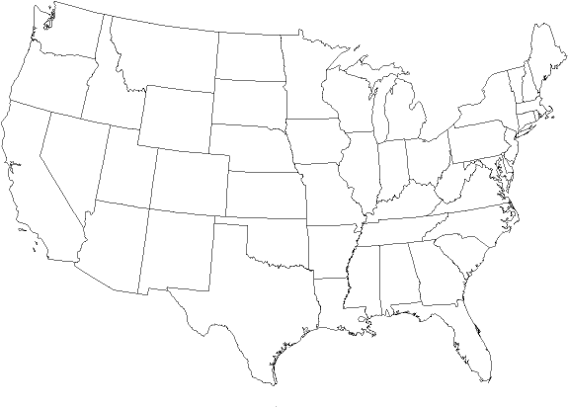

**THE AMISH**4. Where did Amish culture originate and how did it diffuse to the United States?

5. In what ways is Amish culture distinct from the popular culture of the United States?

What is happening to the Amish in the United States today?

6. Use dots to identify the Amish core area. Label each of the states which have large numbers of Amish.

7. How was soccer transformed from a folk custom into popular culture?

MCj01988280000[1]

8. Despite their anonymous folk origins, what characteristics of organized spectator sports today characterize them as popular culture?

9. Draw a small graphic in the space below to link popular sports with the countries in which they are most popular and with which they are best associated.